1 September 2025
Dear Patient,
Proposal to merge Links Road Surgery and Wish Park Surgery
We are writing to inform you that we are considering a proposal to merge Links Road Surgery, 27-29 Links Rd, Brighton and Hove, Brighton BN41 1XH with Wish Park Surgery, 191 Portland Rd, Brighton and Hove, Hove BN3 5JA, and wish to hear your views so we can ensure they are considered in future decision making. Our intention to close the Links Road site and for all services to be consolidated at the Wish Park Surgery site in Hove.
By combining our teams, we’ll build an even stronger and more resilient team offering access to a larger team and increase the availability of an appropriately skilled clinical workforce, more appointment options, and a wider range of healthcare professionals. By coming together, we aim to Bringing together these surgeries will help ensure the long-term delivery of safe, effective, and sustainable primary care for the local community. Both surgeries have a strong tradition of delivering high-quality, patient-centred care, supported by dedicated and experienced teams.
Why will services be consolidated at Wish Park?
Unfortunately, the premises at Links Road Surgery are no longer fit for purpose. Many consultations take place on the upper floor, and due to structural limitations, it is not possible to install a lift or make the necessary modifications to ensure full accessibility for all patients and staff. The Wish Park surgery is a purpose-built surgery with all rooms situated on the ground floor supporting all patients to better access their care.
We want to hear from you
To help us understand the impact of this proposal and to give your view, we invite you to complete our anonymous patient survey. This survey will be open for the next 5 weeks. It will take just a few minutes and will provide valuable insight into what matters most to you. You can:
- Complete the survey online: https://forms.cloud.microsoft/e/z7KXxtxK1f
- Pick up a paper copy at your surgeries’ reception
- Use the QR code available at the end of this letter, on our website or in our practice
- Call our dedicated answer phone line on 01273 412585 and leave a message. All messages will be listened to, but you may not receive a response.
- Email your feedback to our dedicated email address: sxicb-bh.merger@nhs.net

We greatly appreciate your continued support during this time of change. Patient care remains at the heart of everything we do, and we are committed to making any transition as smooth as possible for you.
Warm regards, 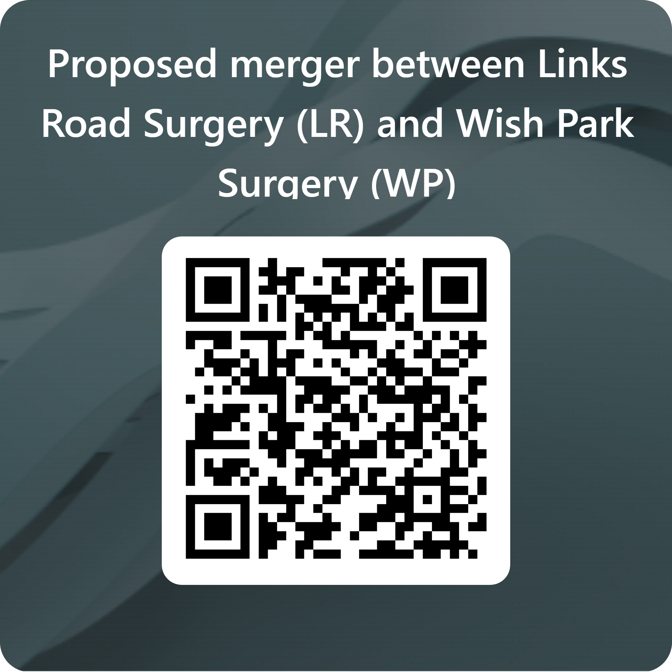
Wish Park Surgery and Links Road Surgery
Questions FAQ’s
Why is this happening?
We’re merging to improve patient care. By combining our teams, we’ll offer access to a larger, more skilled clinical workforce, more appointment options, and a wider range of healthcare professionals.
When will the merger take place?
We’re currently consulting with patients to understand the impact of the proposed merger over the next 5 weeks. Once feedback is received and reviewed, we’ll apply to the Integrated Care Board (ICB). If approved by the ICB, we’ll share a timeline of next steps. We are also making building improvements at Wish Park Surgery separate from this merger proposal to support better services.
What will the practice be called?
The practice will be called Wish Park Surgery

What are the benefits of the merger?
- More healthcare professionals available
- Greater flexibility in appointments
- Improved facilities
- Reduced reliance on temporary staff
- Services tailored to local needs

Will I have to re-register?
No, your records will be transferred to Wish Park Surgery, both surgery’s use the same clinical computer system.

Will my personal data be safe?
Yes, your data will remain secure and protected.

Will I still be able to see my usual doctor and/or nurse?
Yes, you will still be able to see the clinician you usually see. We value continuity of care and want our patients to feel at home at Wish Park. While you may occasionally see a different clinician, rest assured that the existing team at Wish Park is highly skilled, welcoming, and committed to providing excellent care. We are confident you will feel comfortable getting to know the extended team.

Can I still make appointments the same way?
Yes, all existing methods of making appointments remain the same at both surgeries. You can continue to book appointments using the contact options with which you are familiar.

Will the location of the practice be changed?
Yes. All appointments will be held at Wish Park surgery on Portland Road in Hove. The address is: 191 Portland Rd, Brighton and Hove, Hove BN3 5JA.

How can I travel from Portslade to Wish Park if I do not have a car?
You can reach Wish Park easily by bus, with frequent services like the 1, 1X, 6, 49, 700, N1, and 71 stopping nearby. The journey typically takes 10–20 minutes, followed by a short walk. Cycling is also a convenient option, with bike-friendly routes and an estimated travel time of 10–15 minutes. For the most suitable route please use the Brighton & Hove Buses journey planner.

Is parking available at Wish Park?
Wish Park does not have a patient car park, however there is plenty of on-street parking surrounding the practice. There are parking restrictions locally between 10 and 11 am; otherwise, street parking is free of charge.

Will the surgery phone number and email address change?
If the merger goes ahead the number would change to Wish Parks contract information.

Will I have to wait longer on the phone to get through if there is only one phone number?
No, as all staff will be relocating to work at Wish Park Surgery.

Will the opening times of the practice be changed?
No, the practice will continue to be open during core hours, 8:30am to 6:00pm, Monday to Friday.

Will any services currently offered be stopped?
No, we do not have any plans to stop any services as a result of the merger.

Will there be any changes to GP out-of-hours service?
No, services will continue as normal.

Will the merger affect my ongoing care at the practice?
No, your ongoing care will not be disrupted by the proposed merger. You will continue to see your usual doctor or nurse, order repeat medication, use your preferred pharmacy, and make appointments in the same way as before. We believe the merger will strengthen our services by combining the expertise and resources of both practices, giving you access to a more resilient, multi-skilled team and greater flexibility in how care is delivered.

How will maintain quality of care?
The existing Practice Manager and clinical leadership team remain the same across both Wish Park and Links Road, ensuring continuity and consistency in care. We see this merger as a valuable opportunity to bring together the best systems and processes from both practices. Maintaining and improving the quality of patient care is our top priority and will be a key measure of the merger’s success. If you have any specific questions or concerns, please do not hesitate to get in touch—we are here to help, Emma, Tom and Dr Amin would love to hear from you.

Will I still be able to order repeat medication and use my usual pharmacy?
Yes, you will still be able to order your repeat medication in the usual way and continue using your preferred pharmacy. There will be no changes to the current process, so you can manage your prescriptions just as you always have.

Will the practice website change?
No, the format and layout of the website is currently the same for both practices. Patients can continue to access information, book appointments, and use online services just as they do now, without any disruption.

What will happen to Patient Participation Groups (PPGs)?
If the proposal is taken forward, we will combine the existing PPGs from Wish Park and Links Road. We will be speaking to the chairs from both PPGs and the wider PPG teams to discuss how the combined group will look in the future. PPGs and patient engagement are a priority and key focus for both practices, and we will look to grow our PPG. We value patient opinion and feedback and the larger our PPG, the bigger the patient voice. We would very much welcome new members.

Does this mean the practice will be private?
No, the practice will continue to operate as an NHS service. There is no change to our existing contract to provide NHS care to our local community. Patients will still receive the same high-quality services without any private fees, and all care will remain free at the point of use, as part of the NHS.

I am housebound and require home visits, will this service still be available?
Yes, home visit services will continue to be available for housebound patients. The merger will strengthen our clinical team, allowing us to maintain and improve essential services like home visits.

Will Practice boundaries change?
Yes, the boundaries of both practices will be combined into a single, unified practice area. This means patients registered at either Wish Park or Links Road will be part of the same catchment area.

