Standard Reporting Template – Patient Participation DES 2014/15
Surrey & Sussex Area Team

Practice Name Wish Park Surgery

Practice Code G81083

Signed on behalf of practice 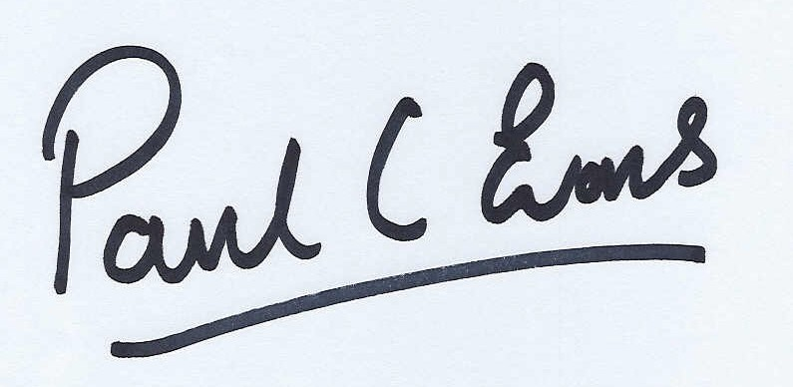Date 25/3/2015

Signed on behalf of PPG Sylvia New Date 25/3/2015

- Prerequisite of Enhanced Service – Develop/Maintain a Patient Participation Group (PPG)

Does the Practice have a PPG? YES / NO | Yes
Method of engagement with PPG: Face to face, Email, Other (please specify) | Face to face, email, post
Number of members of PPG: | 36

Detail the gender mix of practice, population and PPG: | Detail of age mix of practice population and PPG:
% Male Female  Practice 48 52  PPG 50 50 | % <16 17-24 25-34 35-44 45-54 55-64 65-74 >75  Practice 21 6 13 18 15 10 8 9  PPG 0 1 4 11 12 20 40 12
Detail the ethnic background of your practice population and PPG:

White |  |  |  |  | Mixed/ multiple ethnic groups
% | British | Irish | Gypsy or Irish Traveller | Other white | White Black & Caribbean | White & black African | White & Asian | Other mixed
Practice
PPG

 | Asian/ Asian British |  |  |  |  | Black / African / Caribbean  / Black British |  |  | Other
% | Indian | Pakistani | Bangladeshi | Chinese | Other Asian | African | Caribbean | Other Black | Arab | Any Other
Practice
PPG

Describe steps taken to ensure that the PPG is representative of the practice population in terms of gender, age and ethnic background and other members of the practice population:
PPG well-advertised with leaflets, posters, website access, open evenings, stalls at local events, meetings with local community groups and organisations

Are there any specific characteristics of your practice population which means that other groups should be included in the PPG? e.g. large student population, significant number of jobseekers, large numbers of nursing homes or a LGBT community? YES/NO
Large number of nursing homes

If you have answered yes, please outline measures taken to include those specific groups and whether those measures were successful:

Met with managers of local homes asking for their input, with 3 included in PPG email correspondence

- Review of patient feedback
Outline the sources of feedback that were reviewed during the year:

Patient survey
Friends and family test
Meetings

How frequently were these reviewed with the PPG?

Bi monthly at meetings

- Action plan priority areas and implementation
Priority area 1
Description of priority area:
Ability to get through on the telephone-particularly early in the morning

What actions were taken to address the priority:

Resource has been put into the early part of the day, to increase the ability to answer phones. Additionally, more lines were added to the system, and on our planned move, we will add additional features to give better information

Result of actions and impact on patients and carers (including how publicised):

Patients aware that it is a busy part of the day and can be more perception that reality. No recent complaints directly to the surgery and changes planned have met with approval
Publicised PPG minutes

Priority area 2
Description of priority area:
Patients Privacy

What actions were taken to address the priority:

The surgery is due to move in 2015, and it was accepted that little can be done within the current premises. Music was discussed but some patients like it and some don’t. Overall, agreed to way until we move to review and include patients in the design of the new surgery where possible

Result of actions and impact on patients and carers (including how publicised):

Staff are aware of need to be considerate when dealing with patients. Several meetings held with patients able to give input to the patient ares for the new surgery

Priority area 3
Description of priority area:
Disability Access

What actions were taken to address the priority:

Agreed that the current building makes access difficult but GP’s have agreed to use the downstairs rooms where possible, with staff booking appropriately.
The new building is on 1 floor with excellent disabled access

Result of actions and impact on patients and carers (including how publicised):

No recent feedback indicating that the surgery is not trying to help where it can. New building due to complete June 2015
Publicised on minutes and website

Progress on previous years
If you have participated in this scheme for more than one year, outline progress made on issues raised in the previous year(s)
Free text
Previous issues included seeing a GP of choice, waiting times and consultations.
Recent feedback about the surgery has been very positive from several sources including Friends and family and NHS choices. The surgery appointment levels have been compared to other local surgeries and we offer more sessions than the majority of our peers. Where possible, a GP will be booked with a GP requested

- PPG Sign Off

Report signed off by PPG: YES / NO | Yes
Date of sign off: | 25/3/2015
How has the practice engaged with the PPG: | Yes
How has the practice made efforts to engage with seldom heard groups in the practice population? | Yes
Has the practice received patient and carer feedback from a variety of sources? | Yes
Was the PPG involved in the agreement of priority area and the resulting action plan? | Yes
How has the service offered to patients and carers improved as a result of the implementation of the action plan? | Yes
Do you have any other comments about the PPG or practice in relation to this area of work? | The PPG and practice is working well together and going from strength to strength

