ENHANCED TELEPHONE SERVICE AVAILABLE SOON
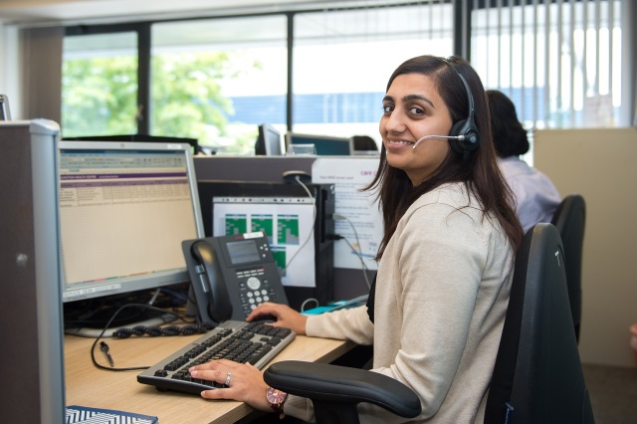
Wish Park Surgery, Hove
We know it can be difficult to obtain an appointment with a GP.
Part of the reason is that many face-to-face appointments are used for problems that could be better dealt with over the telephone. Similarly, patients who wish to discuss something over the telephone have to queue for a face-to-face because they have difficulty getting a telephone consultation.

From 1st November 2018 the practice will be trialling a new telephone consultation service. This will be provided by Care UK, working in partnership with the practice. The service is commissioned by NHS England and has been running in GP practices in other areas of the country.
HOW IT WORKS
When you call the surgery, your details will be taken and a GP will call you back within an allocated time slot on the same day. The Care UK GP will have full access to your medical records and all the same services that the Wish Park Surgery GP would have, including prescriptions, fit notes, investigations and referrals.
If you need to be seen for a face-to-face appointment following your telephone consultation, you will be booked in with a clinician later that day.
This new service will increase access to medical appointments and we hope that our patients will find it beneficial. We appreciate your patience whilst these changes are taking place.
If you have any queries or would like more information, please speak to a member of the reception team. Thank you.

